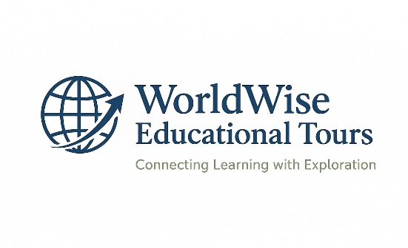
Proposal for Partnership with the Ministry of
Education and Training

- Introduction
WorldWise Educational Tours Agency is dedicated to providing experiential learning opportunities for students and educators. We believe that education goes beyond the classroom, and through strategic partnerships, we aim to provide learners with access to national, regional, and international educational experiences that broaden knowledge, inspire innovation, and strengthen global citizenship.

- Objectives of the Partnership
The partnership between WorldWise Educational Tours and the Ministry of Education and Training seeks to achieve the following objectives:
- Enhance students' exposure to real-world learning environments. - Strengthen alignment with national education goals and policies.
- Provide professional development opportunities for teachers and educators.
- Foster cultural appreciation, global awareness, and international cooperation.
- Improve educational outcomes through innovation and applied learning experiences.

- Proposed Programs
WorldWise Educational Tours proposes the following programs for implementation in collaboration with the Ministry of Education and Training:
- Local and Cross Boarder Educational Tours – Visits to national institutions, industries, historical sites, and centers of innovation.
- Regional Exchange Programs – Cross-border tours within Southern Africa to strengthen regional integration and cultural appreciation.
- International Study Tours – Exposure to advanced educational systems, global institutions, and cultural experiences.
- Teacher Development Tours – Professional learning opportunities for educators through study tours, seminars, and international exchanges.
- Presidential School Exchange – Special focus programs for learners in National/Presidential Schools to gain global insights.

- Implementation Plan
The programs will be implemented through a phased approach: -
Phase 1: Pilot educational tours within Eswatini and cross-boarder tours
Phase 2: Regional exchange programs with neighbouring countries
Phase 3: Expansion into international study tours
Phase 4 :WorldWise Educational Tours will work closely with the Ministry to align programs with the academic calendar and ensure inclusivity across schools.

- Long-Term Growth Vision
- Partner with international NGOs or exchange programs
- Create Africa-wide student travel networks
- Host annual student summits or camps
- Offer educational scholarships tied to travel

- Financial Framework
The financial structure will be based on a cost-sharing model involving contributions from the participating schools and partners. WorldWise Educational Tours will ensure transparency and accountability in financial management. A summary of the projected budget is presented below:

Category Estimated Cost (per year, SZL)
Local Tours (logistics & coordination)…...1,200,000
Regional Exchange Programs……….. …2,500,000
International Study Tours ………………. 4,800,000
Teacher Development Programs………. 1,500,000
Administration & Monitoring…………….. 800,000
Total Estimated Annual Budge…………..10,800,000

- Expected Benefits to the Ministry of Education and Training
- Improved quality of education through practical and global exposure. - Strengthened capacity of educators through training and development.
- Enhanced reputation of Eswatini’s education system at the regional and global level.
- Opportunities for international collaboration and partnerships
- Support for national goals on innovation, cultural preservation, and global competitiveness.

- Monitoring and Evaluation
WorldWise Educational Tours will establish a robust monitoring and evaluation framework to track program outcomes. Regular reports will be shared with the Ministry to ensure transparency, accountability, and continuous improvement of the partnership
.
- Conclusion
We believe that this partnership will transform the educational experience of learners and teachers across the Kingdom of Eswatini.WorldWise Educational Tours is committed to working hand in hand with the Ministry of Education and Training to achieve these shared goals. Together, we can prepare our learners for a brighter, globally competitive future.

